UNSTRUCTED DATABASE LAB
LAB 6 ASSIGNMENT
RITTIKA ROY, UG/02/BTCSECSF/2023/025

- Display employee name and salary only.
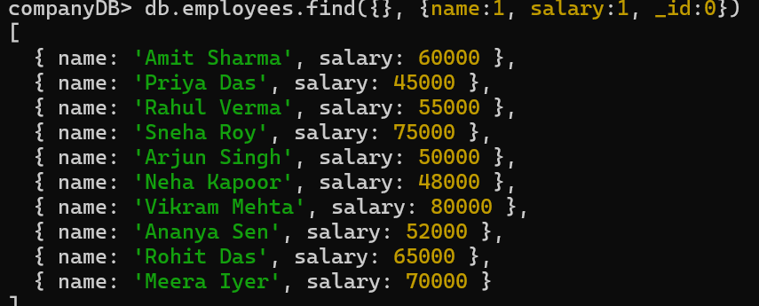

- Find employees working in HR department.
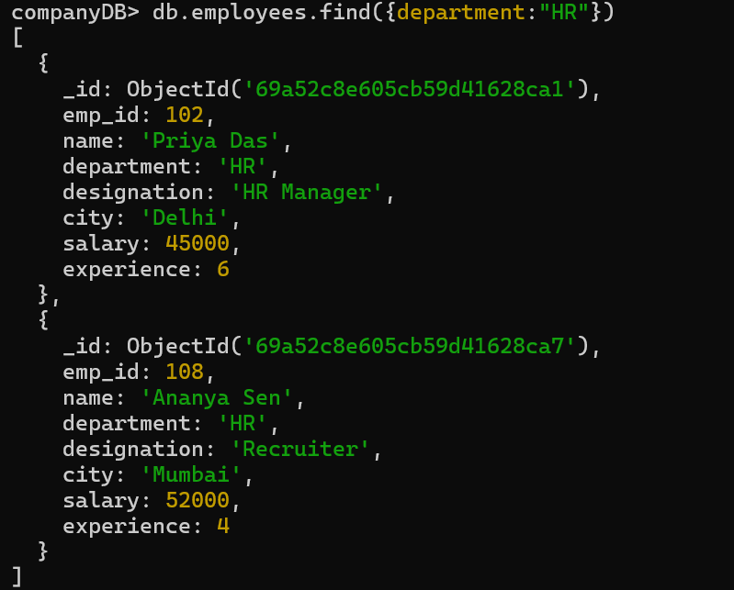
- Find employees whose salary is between 50,000 and 80,000.
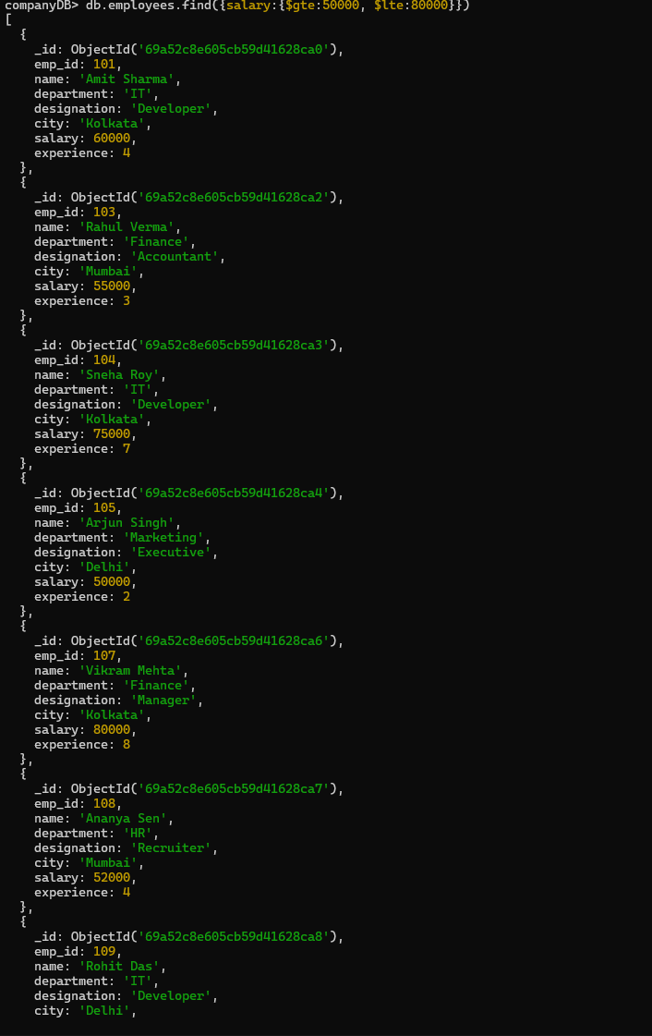
4. Display employees from Kolkata city.
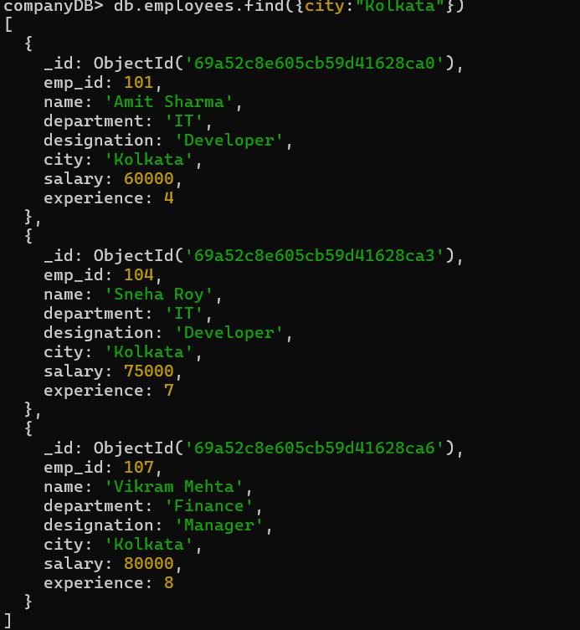

- Sort employees by experience in ascending order.
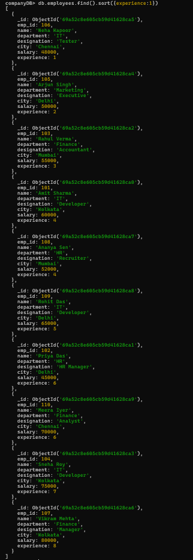

- Display top 5 most experienced employees.
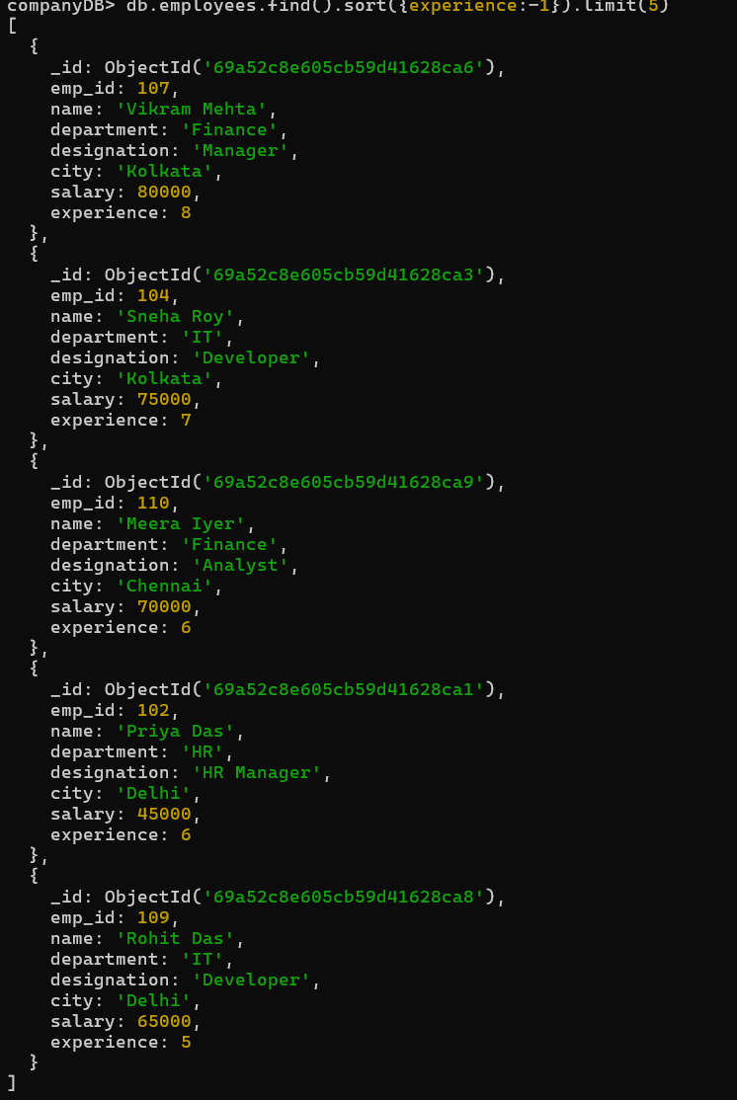
- Update salary of employee with emp_id 102 to 48,000.

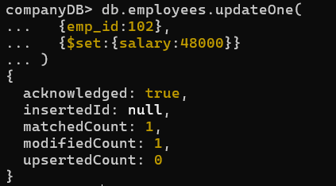

- Increase salary of all IT employees by 10,000.

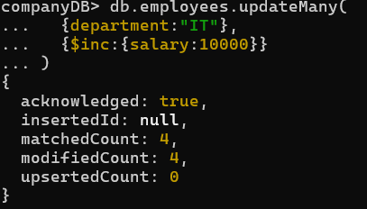

- Update designation to “Senior Developer” for IT employees having experience more than 5 years.
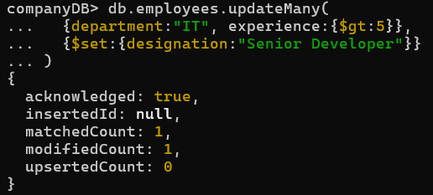
- Delete employees whose experience is less than 2 years.

- Display employees who are not from Delhi.
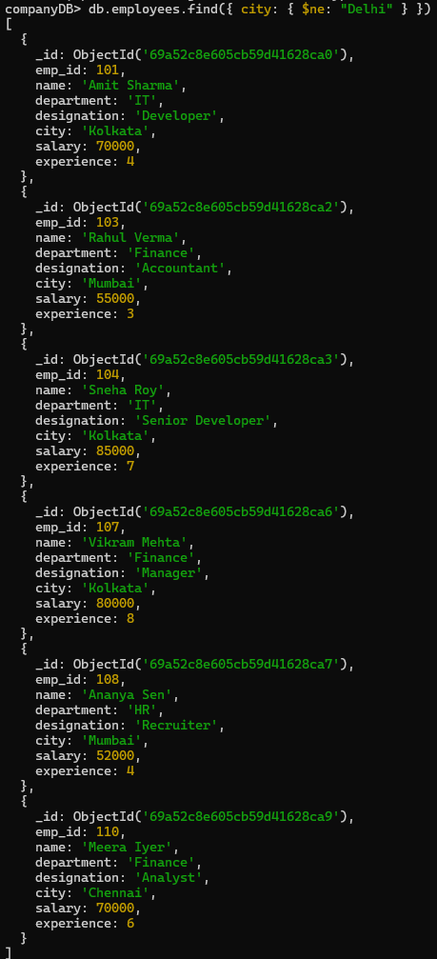
- Find employees whose designation is Developer and salary greater than 60,000.
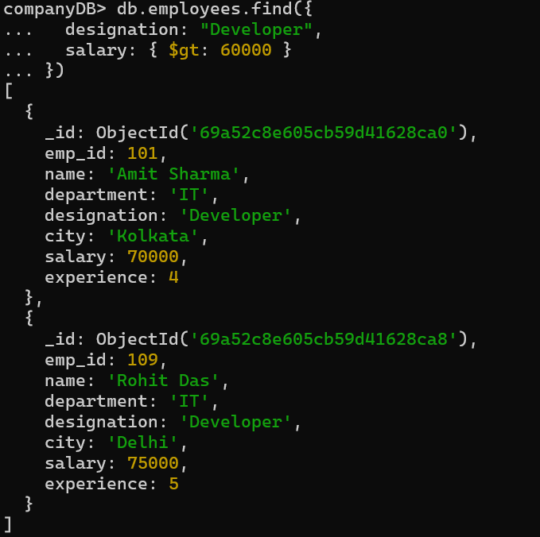

- Display employees working in IT or Finance department.
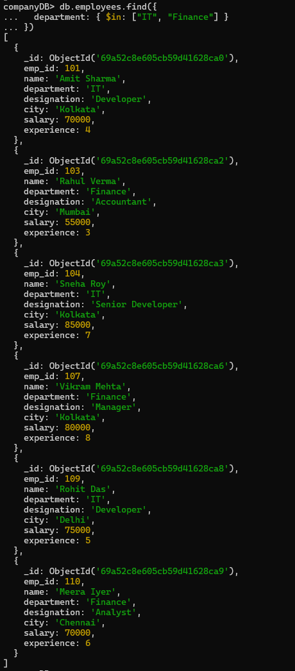

- Display employees sorted by department and then by salary.
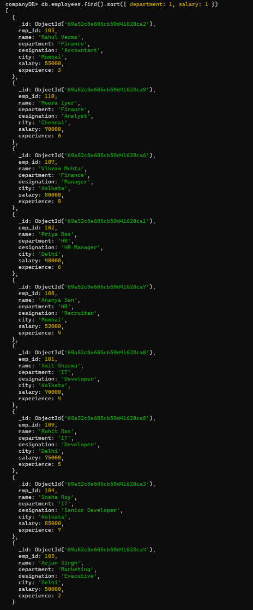
- Count total number of employees in the company.

- Display employees whose salary is not equal to 50,000.
